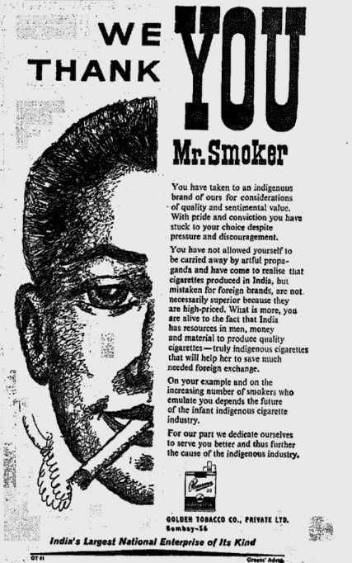

Thank you, Mr. Smoker!

Reads the Headline.

You are elated, and Intrigued.

Someone is grateful for your habit- or as you see it "Shauk".

You continue reading, and the words have a beautiful poetic tone. The sentences make you feel that the praise certainly comes from someone well-read, who sees the deeper values that drive your choices.

They get you. They know why your preference is an act of class, rooted in cultural sensitivity, and patriotism.

You are amongst the people who understand the needs of a newly formed nation.

You believed in "Make in India" decades before it was a thing, and you were a modern believer in the Swadeshi movement.

You believe in the country's ability to produce world-class products- and support it wholeheartedly, not swayed by an inferiority complex that the Westerners left everyone around you with.

You are proud of your identity, you are helping India save her foreign exchange, and you are a rebel who does not give in to pressures and discouragement.

You shall keep smoking for it helps the country, its people, and its identity- while making a statement.

The number of people like you is increasing, and you are leading the charge- you always were ahead of the curve, and are definitely doing something right.

You are helping raise a country, and its businesses from infancy, and your efforts shall be remembered

- as cancer trial subjects.

For people in beSci, marketing, and psychology, the "growth hackers" and the product folks, as much as we talk about ethics and "robust" methodologies, as much as we talk about "knowing what people want" and "how to make them want it more" you need to recognize that your understanding of right and wrong will be rooted in the Zeitgeist.

Looking at this ad might make you uncomfortable now- but it plays on the same sentiments, the same "nudges", the same concepts that we so proudly talk about today- and see market players using.

Nationalism is hot, as is "embracing cultural identity", India becoming a strong economy is hot, as are ads that put down our neighbours.

The ad makes use of social proof, false consensus effect, and self-serving bias- in a time when these concepts were unheard of, words people now throw around to signal intelligence.

When you say you could've known everything wrong about this advertisement, you'll also be falling victim to hindsight bias.

Truth is, regardless of how smart, aware, and "ahead of the curve" we think we are- we almost always know about the same as the best minds of a certain time.

The best minds once prescribed cigarettes for migraines, you saw it as a medicine, then it became a personality trait, so you saw it as a statement, and now it is a health hazard, so you see it as a bad habit.

These are all understandings rooted in the temporalities of smoking- the immediate effect, the "while smoking", and the "after smoking for long enough".

Time teaches best. Be careful in choosing how you look at it.

